Software Engineering Group Project

Word Template

|  |  |
| --- | --- |
| Author: | Chris Price [cjp] |
| Config Ref: | SE_N66_xxx_xx |
| Date: | 20th February 2019 |
| Version: | 1.4 |
| Status: | Release |

Department of Computer Science

Aberystwyth University

Aberystwyth

Ceredigion

SY23 3DB

Copyright © Aberystwyth University 2019

CONTENTS

CONTENTS 2

1. Introduction 3

1.1 Purpose of this Document 3

1.2 Scope 3

1.3 Objectives 3

2. BODY OF DOCUMENT 3

REFERENCES 3

DOCUMENT HISTORY 4

# Introduction

Clear, consistently followed, document standards are essential in software engineering.

## Purpose of this Document

This document is to describe an MS Word template.

## Scope

This supports the standards laid down for CS22120 Group Projects [1].

## Objectives

The objective of this document is to both carry the template and explain a little of how it works.

# BODY OF DOCUMENT

Front material is stored in document properties. These are not the correctly named properties but their use permits automation of running header update. Editing the front material will make changes throughout the document.

Titles, headings, body, bibliography entries, captions and table of content entries are defined as shown in Figure 1

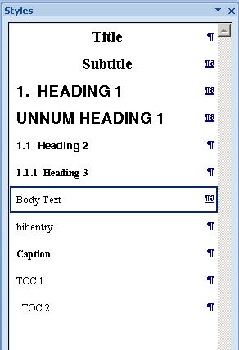

Figure : Recommended styles

REFERENCES

[1] Software Engineering Group Projects: General Documentation Standards. C. J. Price, N. W. Hardy, B.P. Tiddeman. SE.QA.03. 1.8 Release

DOCUMENT HISTORY

| *Version* | *CCF No.* | *Date* | *Changes made to document* | *Changed by* |
| --- | --- | --- | --- | --- |
| 1.0 | N/A | 12/09/08 | N/A - original version | CJP |
| 1.1 | N/A | 2010-10-12 | Updated to Office 2007; key field automation increased; paragraph styles updated | NWH |
| 1.2 | N/A | 2011-10-10 | Typos | NWH |
| 1.3 | N/A | 2015-10-16 | Update for Office 2013 | NWH |
| 1.4 | N/A | 20/02/19 | Made Intro sections have the correct style | CJP |